# Self Declaration

To whomsoever it may concern, I name take the accountability of the project titled “Sentiment Analysis” which has been completed by me.

Github link: <https://github.com/MaliniGeddam/Sentiment-Analysis>

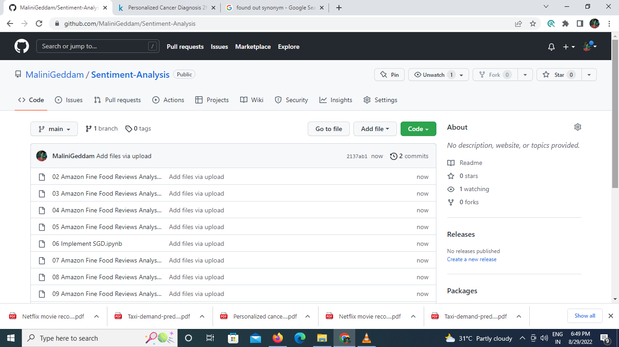

Geddam Malini (21MT61R18)

Date: 29/08/2022